UPPWISE INDIA

www.uppwise.com



**Quaterly Development Planning**

**Q1-2024**

**Feature: Baseline Management**

**Feature Title:**

Baseline Management

**Priority:**

Medium

**Submitted By:**

SPM

**Feature Description:**

In this we are keeping the functionality as it is for now.

**Target Users:**

Standard User

**Acceptance Criteria:**

This document provides a comparative analysis of baseline functionality between SPM and POX, highlighting differences to aid in assessing pertinent functionalities for our customer, AXA, thereby informing our decision-making process moving forward.

1. **Overwriting vs. Multiple Versions in Draft Project State:**
   * **SPM***:* Baselines are overwritten with each new save in the draft state, resulting in only one version available at any given time.

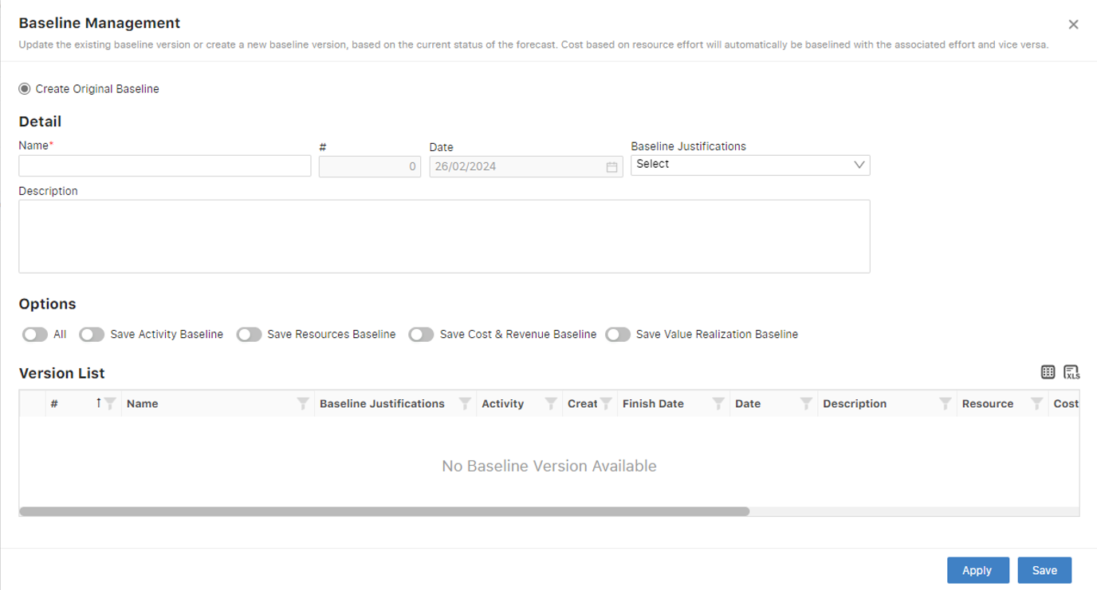

* + **POX:** Users can create and maintain multiple baseline versions in the draft state of the project.

1. **Resource, Task, and Cost Baselines:**
   * **POX:** Offers functionality to save baselines separately for each resource, task, and cost. Users can achieve this by hovering over the respective title.

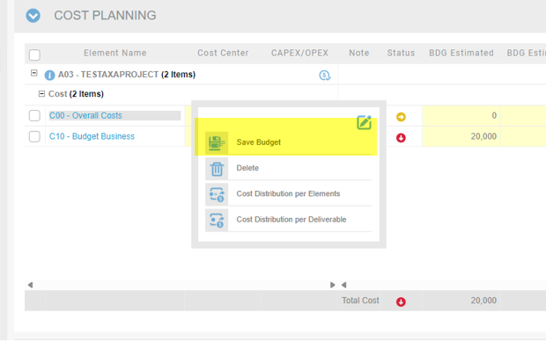

* + **SPM:** Lacks the capability to save individual baselines for resources, costs, and tasks. Baselines for these elements are saved overall from the project workspace.

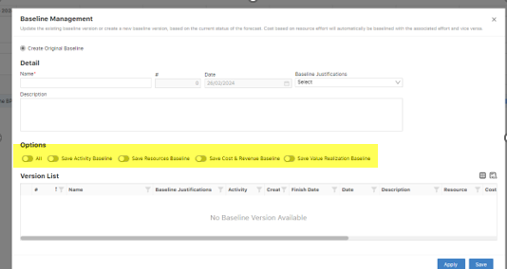

1. **Value Realization Widget (VR) Baseline:**
   * **SPM:** Enables the saving of baseline data for the Value Realization widget, a feature absents in the POX solution.

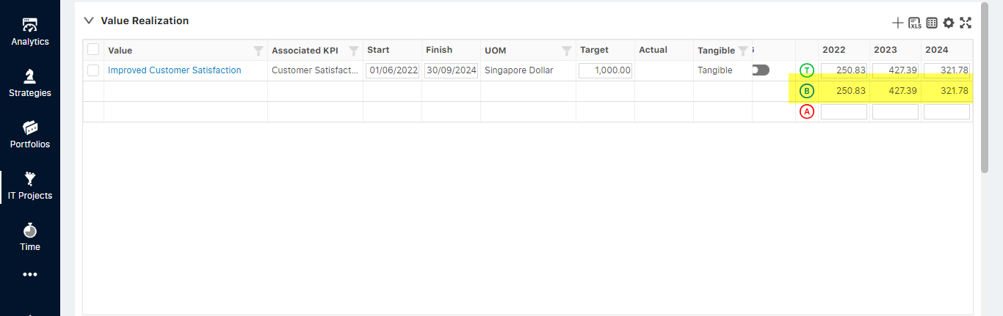

1. **Workflow Baseline Jobs:**

**BASELINE_ALL:**

* + - Procedure used to save the baseline of the project associated with the object.
* Sub-procedures executed:
  + SaveCostsBaseline: Saves Cost/Revenue assignments budget.
  + SaveResourcesBaseline: Saves Resource Assignment baseline.
  + VR_UpdateBaselineVersion: Saves the Value realization baseline and its version.
  + SaveScheduleBaseline: Saves the Scheduled Baseline of the project.
  + SaveBaselineVersion: Saves the New Baseline version of the project associated with the collaboration object.

**BASELINE_RCV:**

* Procedure saves baseline of Resource, Cost, and Value Realization for the Initiative associated with the object.
* Sub-procedures executed:
  + SaveCostsBaseline
  + SaveResourcesBaseline
  + VR_UpdateBaselineVersion
  + SaveBaselineVersion
    - Differs from "BASELINE_ALL" by not saving the scheduled baseline.

**BASELINE_S:**

* + - Procedure saves Scheduled baseline and updates the baseline version.
    - Sub-procedures executed:
      * SaveScheduleBaseline
      * SaveBaselineVersion

**SaveBaselineVersion:**

* + - Updates the version of the baseline.

**SP_UPDATEDEMANDBASELINE:**

* + - Previous version to save initiative baselines (Resource, Cost, and initiative baseline dates).
    - Does not update the version of the baseline or VR baseline.